MGT 40750 – Quantitative Decision Modeling Spring 2017

**Solution to Assignment 2: Linear Programming**

There are four questions (15 total points) in this assignment. All relevant Excel files can be found on Sakai. Solve these questions in Excel and fill in the solution template provided below.

**Question 1: Problem 50 on page 200 in the Practical Management Science (PMS) 5th Ed textbook (just do part a).**

Step 1: Specify the Excel file Question1.xlsx. Make sure to record *all the necessary formulas*.

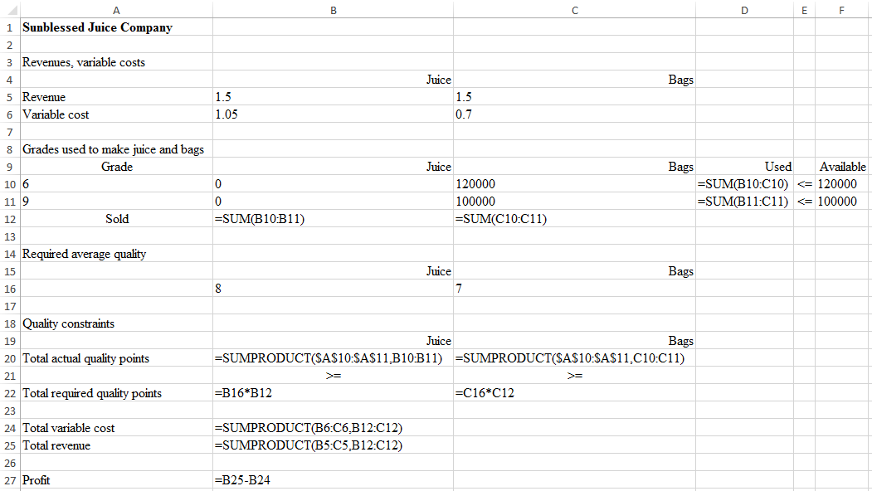

Step 2: Specify Solver

Set Objective: B27

To: X Max ○ Min ○ Value of: _________

By Changing Variable Cells: B10:C11

Subject to the Constraints:

|  |
| --- |
| B20:C20 >= B22:C22  D10:D11 <= F10:F11 |

X Make Unconstrained Variables Non-Negative

Select a Solving Method: Simplex LP

Step 3: Report your results below.

|  |  |  |
| --- | --- | --- |
| Grades used to make juice and bags | | |
| Grade | Juice | Bags |
| 6 | 0 | 120000 |
| 9 | 0 | 100000 |

The optimal profit is $176,000.

*Step 4: Sunblessed Juice Company is considering purchasing more grade 9 oranges. How much would you be willing to pay for additional 1,000 pounds of grade 9 oranges?*

We are willing to pay $800 in total, or $.8 per pound, for 1,000 pounds of grade 9 oranges.

Explain your answer.

We rerun the model with available grade 9 oranges set to 100,000 + 1,000 = 101,000. The resulting profit is $176,800. Thus we are willing to pay $176,800 - $176,000 = $800 in total for 1,000 pounds of grade 9 oranges, which translates to a unit price of $800 / 1,000 = $.8.

**Question 2: Problem 51 on page 200 in the PMS 5th Ed textbook.**

Step 1: Specify the Excel file Question2.xlsx. Make sure to record *all the necessary formulas*.

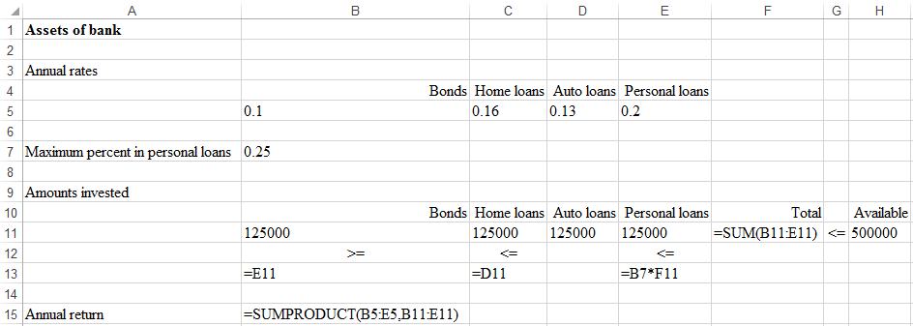

Step 2: Specify Solver

Set Objective: B15

To: X Max ○ Min ○ Value of: _________

By Changing Variable Cells: B11:E11

Subject to the Constraints:

|  |
| --- |
| B11 >= B13  C11 <= C13  E11 <= E13  F11 <= H11 |

X Make Unconstrained Variables Non-Negative

Select a Solving Method: Simplex LP

Step 3: Report your results below.

|  |  |  |  |
| --- | --- | --- | --- |
| Amounts invested | | | |
| Bonds | Home loans | Auto loans | Personal loans |
| $125,000 | $125,000 | $125,000 | $125,000 |

The optimal annual return is $73,750.

**Question 3: Problem 60 on page 202 in the PMS 5th Ed textbook.**

Step 1: Specify the Excel file Question3.xlsx. Make sure to record *all the necessary formulas*.

*Hint: Use B18:C18,B20:C20 as the decision variables.*

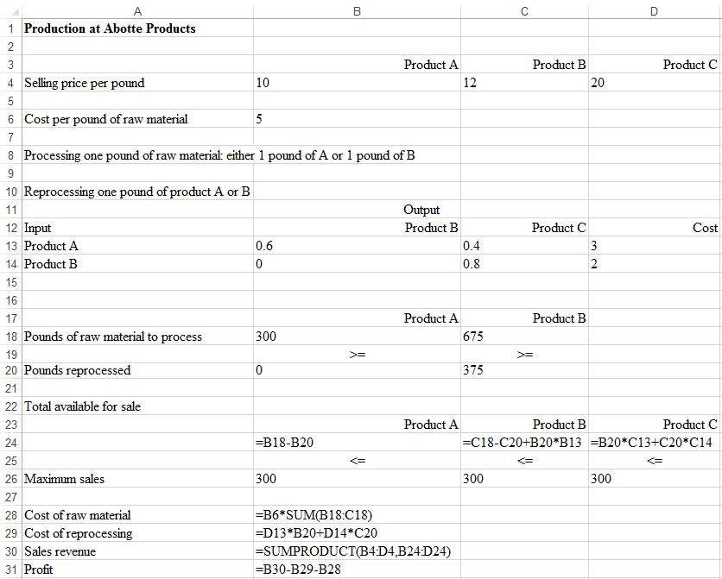

*Step 2: Specify Solver*

Set Objective: B31

To: Max

By Changing Variable Cells: B18:C18,B20:C20

Subject to the Constraints:

|  |
| --- |
| B18:C18 >= B20:C20  B24:D24 <= B26:D26 |

X Make Unconstrained Variables Non-Negative

Select a Solving Method: Simplex LP

*Step 3: Report your results below.*

|  |  |  |
| --- | --- | --- |
|  | Product A | Product B |
| Pounds of raw material to process | 300 | 675 |
| Pounds reprocessed | 0 | 375 |

The optimal profit is $6,975.

**Question 4: Problem 95 on page 207 in the PMS 5th Ed textbook (just do part a).**

Step 1: Specify the Excel file Question4.xlsx. Make sure to record *all the necessary formulas*.

*Hint: Use B14:E15 as the decision variables.*

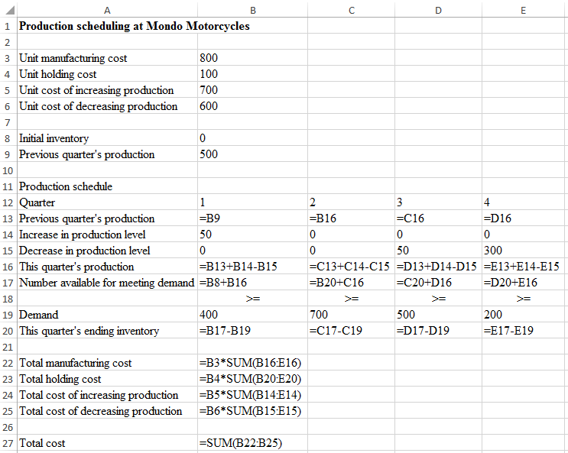

Step 2: Specify Solver

Set Objective: B27

To: ○ Max X Min ○ Value of: _________

By Changing Variable Cells: B14:E15

Subject to the Constraints:

|  |
| --- |
| B17:E17 >= B19:E19  (or equivalently, B20:E20 >= 0) |

X Make Unconstrained Variables Non-Negative

Select a Solving Method: Simplex LP

Step 3: Report your results below.

|  |  |  |  |  |
| --- | --- | --- | --- | --- |
| Quarter | 1 | 2 | 3 | 4 |
| Increase in production level | 50 | 0 | 0 | 0 |
| Decrease in production level | 0 | 0 | 50 | 300 |

The optimal total cost is $1,700,000.